SEQUENCING THE PLAYING CARDS

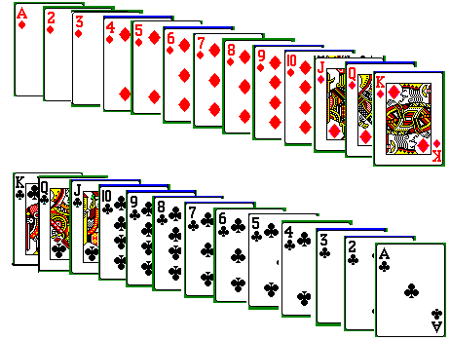

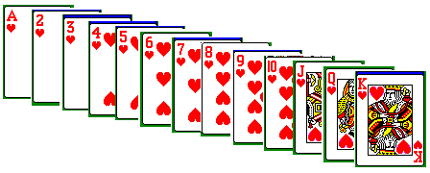

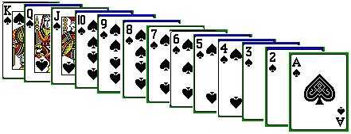

INTRODUCTION OF THE GAME

Shuffle any one suit of 13 cards (one color) in any way. The top card (1st) from shuffled suit should go to the bottom of the set and the next top card (2nd) should be opened. The following top card (3rd) should go to the bottom of the set and next top card (4th) from the set should be opened and so on. When only one card is left, open the card for display with the previously opened cards. The opened cards should display the given sequence (Like: A, 2, 3, 4, 5, 6, 7, 8, 9, 10, J, Q, and K). Once this problem is accomplished, the given sequence could be in any order, not necessarily in the order of card value (Like: 7, 2, K, 10, ….. 5, Q).

SHUFFLED SET OF CARDS

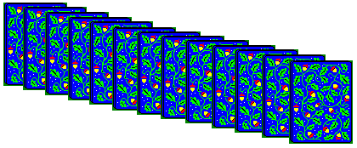
CARDS TO GO TO THE BOTTOM OF THE STACK

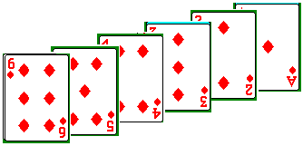
CARDS TO BE OPENED FOR DISPLAY



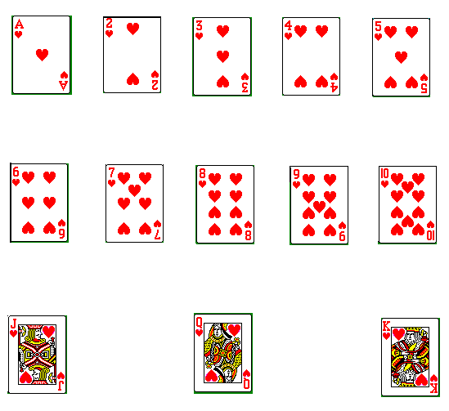

This is the given sequence, and the opened cards should display like.

STRATEGY FOR SEQUENCING THE PLAYING CARDS

To start with, consider the cards to be opened in the sequence of card value, A, 2, 3, 4, 5, 6, 7, 8, 9, 10, J, Q, and K. There are 13 cards in the suit of any given color. When the algorithm works with the above sequence, next the algorithm works for any given sequence of cards.

13 / 2 = 6

13 - 6 = 7

Place the first 6 cards in array 0, there are 7 cards remaining.

7 / 2 = 3

7 - 3 = 4

Place the next 3 cards in array 1, there are 4 cards remaining.

4 / 2 = 2

4 - 2 = 2

Place the next 2 cards in array 2, there are 2 cards remaining.

2 / 2 = 1

2 - 1 = 1

Place the next 1 card in array 3, there is 1 card remaining.

Place the remaining card in array 4.

There are 5 distinct arrays of cards
[ A, 2, 3, 4, 5, 6 ] , [ 7, 8, 9 ], [ 10, J ], [ Q ], [ K ].

STRATEGY FOR SEQUENCING THE PLAYING CARDS (contd)

Two queues are maintained, one for the shuffled cards, and the other for opened cards. The shuffled queue is initially empty until the cards are inserted. Insert cards from the arrays into shuffled queue in such a way to display the sequence in the opened queue. The top card and the bottom card represent the front and rear of the shuffled queue respectively. The opened queue is initially empty, which will be filled with an insert as we open the cards from the shuffled queue.

Array 0 Array 1 Array 2 Array 3 Array 4
[ A, 2, 3, 4, 5, 6 ] , [ 7, 8, 9 ], [ 10, J ], [ Q ], [ K ].
Swap
Swap the array for which the division was even division and even remainder, 10 and J are swapped.

Array 0 Array 1 Array 2 Array 3 Array 4
[ A, 2, 3, 4, 5, 6 ] , [ 7, 8, 9 ], [ J, 10 ], [ Q ], [ K ].

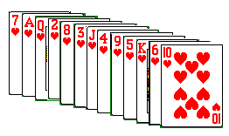
shuffled cards when you see the cards from bottom

Shuffled queue does not display the cards

Opened queue displays cards and their value

The opened queue, this was also the given sequence of cards:

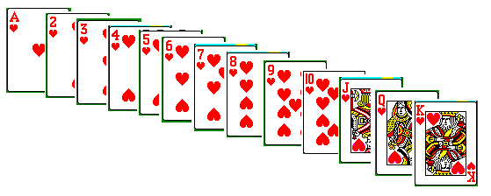

steps for sequencing the cards:

Initially the shuffled queue and opened queue both are empty.

Array 0 Array 1 Array 2 Array 3 Array 4
[ A, 2, 3, 4, 5, 6 ] , [ 7, 8, 9 ], [ J, 10 ], [ Q ], [ K ].

Step 1 Insert array[1][0] into shuffled queue
Step 2 Insert array[0][0] into shuffled queue
Step 3 Insert array[3][0] into shuffled queue
Step 4 Insert array[0][1] into shuffled queue
Step 5 Insert array[1][1] into shuffled queue
Step 6 Insert array[0][2] into shuffled queue
Step 7 Insert array[2][0] into shuffled queue
Step 8 Insert array[0][3] into shuffled queue
Step 9 Insert array[1][2] into shuffled queue
Step 10 Insert array[0][4] into shuffled queue
Step 11 Insert array[4][0] into shuffled queue
Step 12 Insert array[0][5] into shuffled queue
Step 13 Insert array[2][1] into shuffled queue

Given sequence of cards: sequence size = 13
J
A
K
2
3
4
5
6
7
8
9
10
Q

Card array:

5 x 7 array

Sub array:

loop as sequence size is greater than 0
While loop iteration 1:

From index = 0 {starting points }
Array number = 0 {starting array}

Array size = sequence size / 2 ---------- { 13 / 2 = 6 }
J
A
K
2
3
4
5
6
7
8
9
10
Q

Sub string from given sequence of array size { 7 }

A

2
3
4
5
6

Sub array:
Strncpy

Card array: array number = 0
A
2
3
4
5
6

Sequence size = sequence size – array size { 13 – 6 = 7 }

from index = from index + array size { 0 + 6 = 6 }
increment array number {1}

While loop iteration 2: Array size = sequence size / 2 { 7 / 2 = 3 }
J
A
K
2
3
4
5
6
7
8
9
10
Q

From index = 7

Sub string from given sequence of array size { 3 }

Sub array:

7

8
9

Strncpy

Card array:
A
3
2
4
5
6
7

array number = 1
7
8
9

Sequence size = sequence size – array size { 6 – 3 = 3 }

from index = from index + array size { 7 + 3 = 10 }
increment array number {1}
While loop iteration 3: Array size = sequence size / 2 { 3 / 2 = 1 }
J
A
K
2
3
4
5
6
7
8
9
10
Q

From index = 10

Sub string from given sequence of array size { 3 }

Sub array:

J

Strncpy

Card array:
A
3
2
4
5
6
7
7
8
9

array number = 2
J

10

reverse

Sequence size = sequence size – array size { 3 – 1 = 2 }

from index = from index + array size { 10 + 1 = 11 }
increment array number {3}

While loop iteration 4: Array size = sequence size / 2 { 2 / 2 = 1 }
J
A
K
2
3
4
5
6
7
8
9
10
Q

From index = 11

Sub string from given sequence of array size { 3 }

Sub array:

Q

Strncpy

Card array:
A
3
2
4
5
6
7
7
8
9

J

10

array number = 3

Q

Sequence size = sequence size – array size { 2 – 1 = 1 }

from index = from index + array size { 11 + 1 = 12 }
increment array number {4}

While loop iteration 5: Array size = sequence size / 2 { 1 / 2 = 0 }

Make sequence size to 1
J
A
K
2
3
4
5
6
7
8
9
10
Q

From index = 12

Sub string from given sequence of array size { 3 }

Sub array:

K

Strncpy

Card array:
A
3
2
4
5
6
7
7
8
9

J

10

Q

array number = 4

K

Sequence size = sequence size – array size { 1 – 1 = 0}

from index = from index + array size { 12 + 1 = 13 }
increment array number {5}

Mult index = 3, modul index = 7, loop count = 3, card sum = 0, col count = 0

Loop loop_count times:

For loop iteration 0:

Card sum = card sum + ( iteration + 1) * mult index { 0 + 1 * 3 = 3 }
Row count = card sum % modul index { 3 % 7 = 3 }

Card array: insert (card array [1][0])
A
3
2
4
5
6

7
8
9

insert (card array [0][0])
J

10

insert (card array [3][0])

Q

insert (card array [0][1])

K

2
A
Q
7

Shuffled queue

4 3 2 1

For loop iteration 1:

Card sum = card sum + ( iteration + 1) * mult index { 3 + 2 * 3 = 9 }
Row count = card sum % modul index { 9 % 7 = 2}

Card array: insert (card array [1][1])
A
3
2
4
5
6

7
8
9

insert (card array [0][2])\
J

10

insert (card array [2][0])

Q

insert (card array [0][3])

K

3

2
A
Q
7

4
J
8

Shuffled queue

4 3 2 1

For loop iteration 2:

Card sum = card sum + ( iteration + 1) * mult index { 9 + 9 * 3 = 18}
Row count = card sum % modul index { 18 % 7 = 4 }

Card array: insert (card array [1][2])
A
3
2
4
5
6

7
8
9

insert (card array [0][4])
J

10

insert (card array [4][0])

Q

insert (card array [0][5])

K

Shuffled queue
3

2
A
Q
7
5
9
4
J
8
K
6

4 3 2 1

final move:

Card array:
A
3
2
4
5
6
7
7
8
9

Insert (card array [2][1])
J

10

Q

K

Shuffled queue
3
10
2
A
Q
7
5
9
4
J
8
K
6

Shuffled queue is ready to open and play

ALTERNATE STRATEGY FOR SEQUENCING CARDS

Given Sequence of Cards in an array:
A
2
4
5
3
6
7
8
9
10
J
Q
K

Initialize current last card of the given sequence of cards
Loop For all cards in the given sequence

Get the current last card from the given sequence of cards

Insert the current last card into the shuffled queue

If the shuffled queue is not empty
Remove the last card from the shuffled queue
Insert the removed card into shuffled queue

Adjust the current last card

End Loop

Shuffled queue:
7
1
2
8
Q
3
J
4
9
5
K
6
10

Iteration 1: Current rear card
A
2
4
5
3
6
7
8
9
10
J
Q
K

Insert
K
Empty shuffled queue
Current rear card into front

K
Shuffled queue
K
Remove rear card

Insert
K
shuffled queue
K
Removed card into front

Iteration 2: Current rear card
A
2
4
5
3
6
7
8
9
10
J
Q
K

Q
K
shuffled queue
Insert into front

K
Q
shuffled queue
K
Remove rear card

K
shuffled queue
K
Q
Insert into front

Iteration 3: Current rear card
A
2
4
5
3
6
7
8
9
10
J
Q
K

J
Q
K
shuffled queue
Insert into front
Q
Q
K
J
shuffled queue
Remove rear card

Insert into front
J
shuffled queue
Q
K

Iteration 4: Current rear card
A
2
4
5
3
6
7
8
9
10
J
Q
K

10
K
J
shuffled queue
Q
Insert into front
K
K
J
Q
shuffled queue
10
Remove rear card

Insert into front
10
shuffled queue
K
Q
J

Iteration 5: Current rear card
A
2
4
5
3
6
7
8
9
10
J
Q
K

10
9
J
Q
shuffled queue
K
Insert into front
9
J
J
Q
10
shuffled queue
K
Remove rear card

Insert into front
9
K
shuffled queue
J
10
Q

Iteration 6: Current last card
A
2
4
5
3
6
7
8
9
10
J
Q
K

9
J
8
Q
K
shuffled queue
10
Insert into
J
8
9
Q
Q
K
shuffled queue
10
Remove card

Insert into
9
10
shuffled queue
Q
J
K
8

Iteration 7: Current rear card
A
2
4
5
3
6
7
8
9
10
J
Q
K

Q
9
J
7
8
K
shuffled queue
10
Insert into
J
8
9

Q
K
shuffled queue
10
Remove card

Insert into
7
Q
9
shuffled queue
10
J
K
8

Iteration 8: Current last card
A
2
4
5
3
6
7
8
9
10
J
Q
K

10
K
J
8
6
Q
9
shuffled queue
7
Insert into

10
Q
7
8

K
J
S Q
9
6
Remove card

Insert into
10
6
7
J
shuffled queue
K
8
Q
9

Iteration 9: Current last card
A
2
4
5
3
6
7
8
9
10
J
Q
K

6
9
8
Q
5
7
J
10
K

Insert into
5
6
K
10

8
7
Q
J
9
remove

Insert into
7
10
Q
6
9
J
8
5
K

Iteration 10
A
2
4
5
3
6
7
8
9
10
J
Q
K

6
K
8
Q
4
7
J
10
5
9
Insert into SQ

10
Q
7
8

K
J
9
4
5
6

7
10
Q
6
J
8
K
5
9
4

Iteration 11: Current last card
A
2
4
5
3
6
7
8
9
10
J
Q
K

4
J
K
Q
7
3
10
8
6
5
9

10
3
Q
7
8

K
6
5
9
4
J

7
10
Q
8
6
5
9
4
J
3
K

Current last card Iteration 12:
A
2
4
5
3
6
7
8
9
10
J
Q
K

3
10
K
5
8
2
Q
9
7
6
J
4

3
10
K
5
8
2
Q
9
7
6
J
4

3
10
K
5
8
2
Q
9
7
6
J
4

Current last card Iteration 13:
A
2
4
5
3
6
7
8
9
10
J
Q
K

A
3
10
K
5
8
2
Q
9
7
6
J
4

A
3
10
K
5
8
2
Q
9
7
6
J
4

A
3
10
K
5
8
2
Q
9
7
6
J
4

ALGORITHM TO SHUFFLE THE CARDS AND PLAY

#define MAXQUEUE 14
#define SEQSIZE 13
#define TRUE 1
#define FALSE 0

struct queue {
char cards[MAXQUEUE];
int front;
int rear;
};

typedef struct queue CARDQUEUE;
/* given sequence to process */
char sequence [MAXQUEUE] =
{'A','2','3','4','5','6','7','8','9','0','J','Q','K','\0'};
/* or */
char sequence [MAXQUEUE] =
{'K','7','4','2','J','9','3','8','5','Q','6','0','A','\0'};
Algorithm for main:

CARDQUEUE shuffled_queue;
CARDQUEUE opened_queue;

CARDQUEUE *shuffqptr = &shuffled_queue;
CARDQUEUE *opendqptr = &opened_queue;

shuffled_queue.front = shuffled_queue.rear = MAXQUEUE - 1;
opened_queue.front = opened_queue.rear = MAXQUEUE – 1;
print given sequence
shuffle (given sequence cards, shuffled queue ptr);
print shuffled_queue
playcards (shuffled queue ptr, opened queueptr);
print opened_queue

void shuffle (given sequence of cards, shuffled queue)
{
card_array[5][7]; /* card arrays to shuffle */
sub_array[MAXQUEUE]; /* card arrays to shuffle */
array_size; /* next array size */
array_num = 0; /* next array number */
seq_size = SEQSIZE; /* which is 13 */
card_sum = 0; /* starting number picked */
loop_count = 3; /* arbitrary number picked */
modul_index = 7; /* arbitrary number picked */
mult_index = 3; /* arbitrary number picked */
from_index = 0; /* starting number picked */

sub_str (given sequence, 0, MAXQUEUE, sub_array);

while (sequence size > 0)
{
compute array size to be sequence size / 2 ;
if (array_size == 0)
initialize array size to 1;
sub_str (given sequence, from_index, array size,
sub_array);
increment from_index by array size;
strncpy (card_array[array number], sub_array,
array size);
if ( (seq_size % 2) == 0)
rev_array (card_array[array_num], array size);

increment array number;
subtract array size from sequence size ;
} /* end of while loop */

for ( i = 0, j = 0, k = 0; i < loop_count; i++)
{
compute card sum to be card sum + (i + 1) * mult_index;
compute j to be card sum % modul_index;
insert (card_array[1][i] into shuffled queue);
insert (card_array[0][k++] into shuffled queue);
insert (card_array[j][0] into shuffled queue);
insert (card_array[0][k++] into shuffled queue);
} /* end of for loop */
insert (card_array[2][1] into shuffled queue );
return;

} /* end of function shuffle */

void playcards (shuffled queue, opened queue)
{
removed card ;
opened items = 0;
while (shuffled queue is not empty )
{
removed card = remove (card from shuffled queue);

if (shuffled queue is not empty)
{
insert (removed card into shuffled queue);
removed card = remove (card from shuffled queue);
}
insert (removed card into opened queue);
increment opened items;
} /* end of while loop */

return;
} /* end of playcards function */

